**Green Society Public School**

**D-22**

**Ratnanagar-7, Sauraha, Chitwan**

**First Terminal Examination-2082**

**Class: Nursery Time: - 2 hrs. F.M.: 50**

**Sub: Maths ‘W’**

|  |
| --- |
| **Name: Roll No.: Sec.:** |
| **­­­­­­­­­­­­ ________________ ______________ OBT.MARKS:**  **INVIGILATOR EXAMINER** |

**1) Match the same numbers. [5]**

1 5

3 2

5 3

2 4

4 1

**2. Circle the same numbers. [6]**

1 = 5 4 1

2 = 3 2 5

3 = 1 2 3

4 = 9 5 4

5 = 5 3 2

6 = 8 6 7

**3. Write the missing numbers. [5]**

1 ______ 3 ______ 5 ______ 7 ______

9 ______

**4. Match the Devanagari numbers. [5]**

1 2

2 1

3 5

4 3

5 4

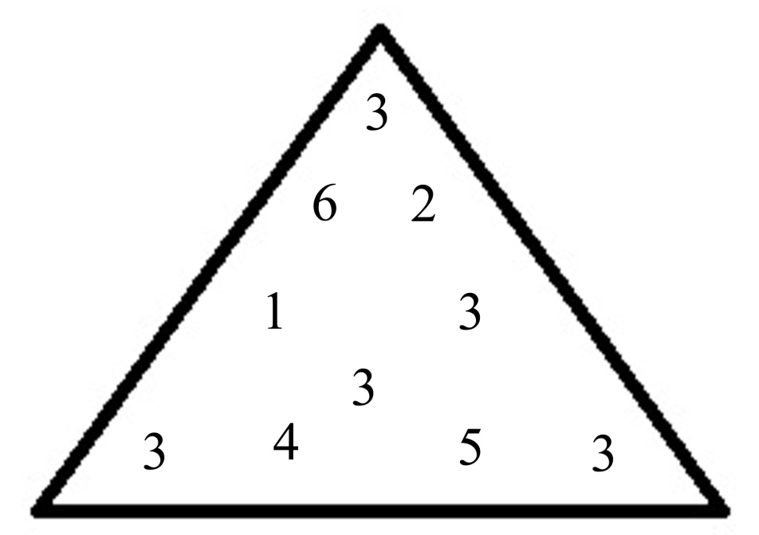**5. Circle the number ‘3’ [5]**

**6. Count and circle the number. [5]**

: 1 4 3

D:\nursery image - all\leaf.jpgD:\nursery image - all\leaf.jpgD:\nursery image - all\leaf.jpg

: 3 2 5



 : 8 7 5



: 2 3 1

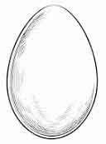

: 5 1 9

**7. Match the same shapes. [5]**

**8. Write the numbers (1 to 5). [10]** ______ ______ ______ ______ _____

**9. Colour the shapes. [4]**

**The End**